**UNAHOTELS Trastevere Roma**

YOUR ROME AWAY FROM HOME

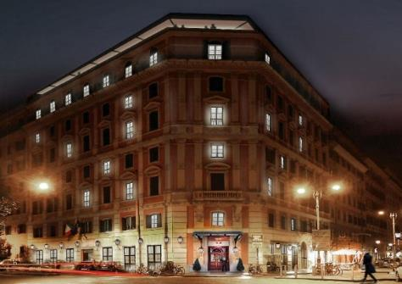**Trastevere** is one of the most distinctive and picturesque places in Rome, **the quarter that really symbolises the city**: true-to-life, colourful, full of places to eat and drink, artisan workshops, and little stores. **UNAHOTELS Trastevere Roma reflects all this** in its own way by bringing the "outside" in, infusing it with deep spaces and plenty of details and overlay effects. Just like a home, the hotel is designed for **families and couples**, but precisely because of its strong character and identity it's the ideal solution too for **business clients** looking for something new and unconventional.

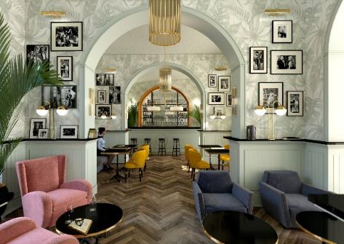Trastevere's Rome comes to life again with the help of this urban regeneration project that gifts the city an **historic palazzo** of 5,200 square metres across 7 floors, built **at the end of the 19th century** as a residential complex for the upper-middle classes.

The reception desk is on the ground floor, as are the lobby with its comfortable lounge area and the elegant, large bar with seating for 30 and views of the private inner courtyard. Everything is finished off with a **warm and welcoming timeless design**.

**THE ROOMS**

The 94 rooms of UNAHOTELS Trastevere Roma reflect the hotel's style in a bright, fresh way, evoking the character of a **beautiful home in Trastevere**. The materials used have a delightfully aged appearance, that as the years go by will raise the hotel to the level of a classic destination 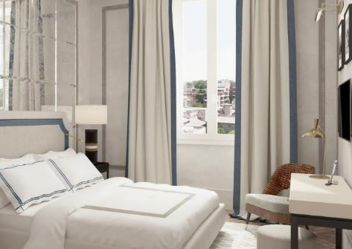in Rome. The books, paintings and ornaments all give off the feel of **natural, "orderly" confusion**.

The available room categories are Superior, Premium, Deluxe, Junior Suite and Suite; particular highlights are the Family Rooms that can sleep **up to 5 people,** and the 5 rooms for reduced mobility guests. Many of the rooms offer a private view of the inner courtyard, but thanks to the **excellent soundproofing,even** those with the view over Trastevere are just as wonderful and peaceful. The **rooms include many features,** such as Smart TV, minibar, safe, free Wi-Fi, universal sockets, a tea and coffee set in superior rooms, bathrooms mostly with shower, some with bath tub, and a CULTI Milano courtesy set.

**THE PANORAMIC ROOFTOP**

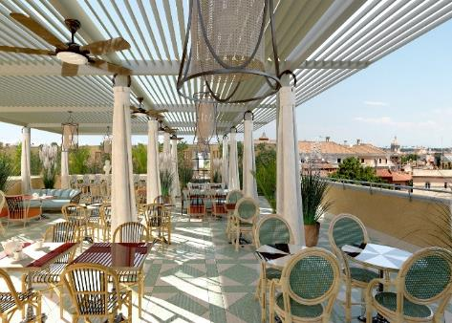The panoramic terrace - home to the rooftop restaurant - is the cherry on the cake, offering **an unrivalled view** across the centre of Rome. All year round, at any time of the day, the large roof and air conditioning system make it the perfect place to admire the panorama from up on the seventh floor, while enjoying **a full breakfast or relaxing aperitifs.**

The rooftop can host around 80 guests and completes this unique hotel in the Rione di Trastevere district perfectly, a hotel aimed not only at visitors to the Eternal City, but also people looking for an **authentic and at the same time discreet experience** in the heart of the capital, or anyone wanting to celebrate an important occasion with friends or colleagues, or organise private or themed events.

**THE INNER COURTYARD**

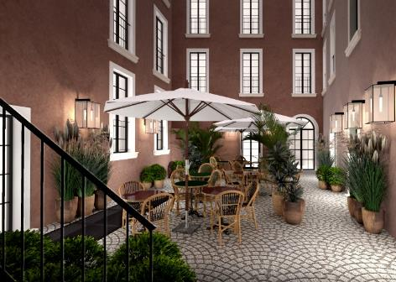

The inner courtyard is a private, intimate space: with seating for around 16 people under elegant umbrellas, it's **a very peaceful corner** in the heart of Rome's lively and bustling Trastevere quarter. Its cobbled flooring is both traditional and iconic at the same time. Mention must be made of the multifunctional room on the ground floor with seating for around 12 people that looks out onto the inner courtyard; the perfect place **for a** **coffee break or a relaxing drink** at the end of the day.

**THE RIONE TRASTEVERE QUARTER**

UNAHOTELS Trastevere Roma stands out too in particular **because of its authenticity and its setting**. Trastevere is one of the most distinctive and picturesque places in Rome, the quarter that really symbolises Roman life. It's genuine, colourful, and full of life, art and history. It's one of the city's busiest places at night, handily located between the Vatican, the city centre and the Rione Testaccio quarter. The artisan workshops, little stores and many places of interest are all things that can be experienced both night and day: **dive into all the art, history and folklore that its heart has to offer.**